**FEATURES**

* Hotel Management
* User Management
* Manage Reports
* Customer Reservation
* Transaction & Report Management

**INCLUDING TABLES**

* Customer
* Room
* Reservation
* Payment
* Employees
* Transactions

**DESCRIPTION**

* **Customer Table:** It will include Customer ID, Customer Name, Customer Reservation, Customer Address, Customer Status, Contact Number.
* **Room Table:** It will include Room ID, Room Type, Room Description.
* **Reservation Table**: It will include Reservation ID, Customer ID, Room ID, Date of Reservation, Check in Date, Check out Date
* **Payment Table:** It will include Payment ID, Customer ID, Payment Type, Payment Date.
* **Employees Table:** It will include Employee ID, First Name, Last Name, Job Department, Address, Contact Number, Username, Password.
* **Transactions Table:** It will include Transaction ID, Transaction Name, Customer ID, Employee ID, Reservation ID, Transaction Date.

**REPORTS**

* General Information Report
* Check-In / Check-Out Report
* Total Revenue Report
* Payment Method Report
* Rooms Reserved in Specific Month Report
* Total Booked Suites Report
* Employees Commission Report
* Dine-In Report

**QUERIES**

**GENERAL INFORMATION REPORT**

SELECT CUSTOMER.CUST_NAME, RESERVATION.RESERVATION_ID, ROOM.ROOM_ID "ROOM_NUMBER", CUSTOMER.STATUS

FROM ROOM, RESERVATION, CUSTOMER

WHERE RESERVATION.CUST_ID = CUSTOMER.CUST_ID AND RESERVATION.ROOM_ID = ROOM.ROOM_ID AND CUSTOMER.STATUS = 'Ready'

**CHECK-IN/CHECK-OUT REPORT**

SELECT CUSTOMER.CUST_ID, CUSTOMER.CUST_NAME, RESERVATION.DATE_IN "CHECK_IN", RESERVATION.DATE_OUT "CHECK_OUT"

FROM CUSTOMER, RESERVATION

WHERE RESERVATION.CUST_ID = CUSTOMER.CUST_ID

ORDER BY CUSTOMER.CUST_ID ASC

**TOTAL REVENUE REPORT**

SELECT CUSTOMER.CUST_NAME, RESERVATION.RESERVATION_ID, ROOM.ROOM_TYPE, ROOMCLASS.PRICE*RESERVATION.DAYS_RANGE "TOTAL"

FROM CUSTOMER, RESERVATION, ROOM, ROOMCLASS

WHERE RESERVATION.ROOM_ID = ROOM.ROOM_ID AND RESERVATION.CLASS_ID = ROOMCLASS.CLASS_ID AND ROOMCLASS.CLASS_ID = ROOM.CLASS_ID AND CUSTOMER.CUST_ID = RESERVATION.CUST_ID

ORDER BY RESERVATION.RESERVATION_ID

**PAYMENT METHOD BY CUSTOMER REPORT**

SELECT CUSTOMER.CUST_NAME, PAYMENT.TYPE, PAYMENT.PAYMENT_DATE, ROOMCLASS.PRICE*RESERVATION.DAYS_RANGE "BILL"

FROM CUSTOMER, RESERVATION, ROOM, ROOMCLASS, PAYMENT

WHERE RESERVATION.ROOM_ID = ROOM.ROOM_ID AND RESERVATION.CLASS_ID = ROOMCLASS.CLASS_ID AND ROOMCLASS.CLASS_ID = ROOM.CLASS_ID AND CUSTOMER.CUST_ID = RESERVATION.CUST_ID AND CUSTOMER.CUST_ID = PAYMENT.CUST_ID

ORDER BY RESERVATION.RESERVATION_ID

**ROOM RESERVED IN SPECIFIC MONTH REPORT**

SELECT CUSTOMER.CUST_NAME, ROOM.ROOM_TYPE, ROOM.ROOM_ID, RESERVATION.RESERVATION_DATE

FROM CUSTOMER, RESERVATION, ROOM, ROOMCLASS

WHERE RESERVATION.ROOM_ID = ROOM.ROOM_ID AND RESERVATION.CLASS_ID = ROOMCLASS.CLASS_ID AND ROOMCLASS.CLASS_ID = ROOM.CLASS_ID AND CUSTOMER.CUST_ID = RESERVATION.CUST_ID AND RESERVATION.RESERVATION_DATE LIKE '%MAR%'

ORDER BY RESERVATION.RESERVATION_ID

**ROOM STATUS REPORT**

SELECT ROOM.ROOM_ID, RESERVATION.RESERVATION_ID, ROOM.ROOM_TYPE, CUSTOMER.STATUS

FROM ROOM, CUSTOMER, RESERVATION

WHERE ROOM.ROOM_ID = RESERVATION.ROOM_ID AND CUSTOMER.CUST_ID = RESERVATION.CUST_ID

**OWNED BOOKED SUITES REPORT**

SELECT ROOM.ROOM_TYPE, CUSTOMER.CUST_NAME, CUSTOMER.STATUS, RESERVATION.RESERVATION_ID, RESERVATION.RESERVATION_DATE

FROM ROOM, CUSTOMER, RESERVATION

WHERE RESERVATION.CUST_ID = CUSTOMER.CUST_ID AND RESERVATION.ROOM_ID = ROOM.ROOM_ID AND ROOM.ROOM_TYPE LIKE '%Suite%'

**EMPLOYEES COMMISSION REPORT**

SELECT EMPLOYEES.EMPLOYEE_ID, EMPLOYEES.NAME, EMPLOYEES.JOB_DEPT, EMPLOYEES.ADDRESS, EMPLOYEES.CONTACT, TRANSACTION.TRANSACTION_NAME, TRANSACTION.TRANSACTION_DATE

FROM EMPLOYEES, TRANSACTION

WHERE TRANSACTION.EMPLOYEE_ID = EMPLOYEES.EMPLOYEE_ID AND TRANSACTION_NAME LIKE '%Commission%'

**DINE-IN REPORT**

SELECT CUSTOMER.CUST_ID, RESERVATION.RESERVATION_ID, CUSTOMER.CUST_NAME, CUSTOMER.RESERVATION, RESERVATION.RESERVATION_DATE

FROM CUSTOMER, RESERVATION

WHERE RESERVATION.CUST_ID = CUSTOMER.CUST_ID AND CUSTOMER.RESERVATION LIKE '%Table%'

**OUTPUTS**

**TABLES**

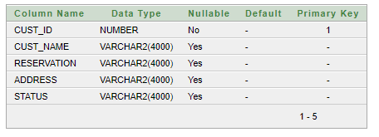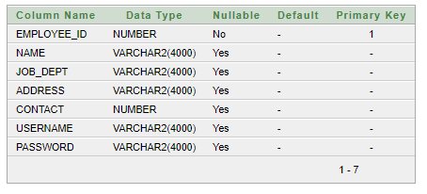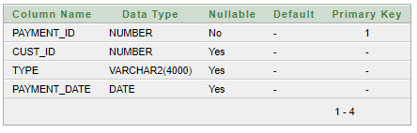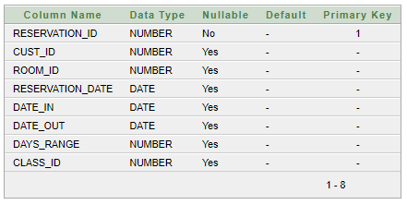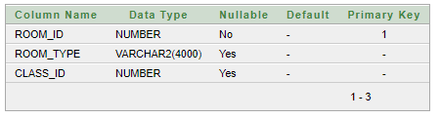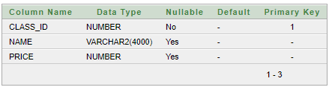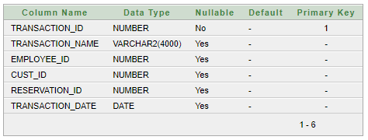

**FORMS**

